**FIND YOUR LAWYER**

Ms. Kavita Joshi1, Chetan Borase2, Ratan Chaurasiya3, Dhiraj Prajapati4, Sanjay Prajapati5

*1Assistant Professor, Department of I.T, Laxmi Institute of Technology, Sarigam*

*2, 3, 4, 5Student, Department of I.T, Laxmi Institute of Technology, Sarigam*

***Abstract: Many law firms work, but let’s talk about India, where many lawyers (approximately 20 lakh approximately) currently have jobs or work under someone else. If a person had to look for a lawyer, he would not know where to go until he had little contact with higher authorities. So, to make this more convenient, we are developing an application called "Find Your Lawyer" which will eliminate these issues. This application will help the client to get lawyers and lawyers to get clients. Those who have no connection in this field can easily hire a lawyer without any confusion. We will bring all kinds of lawyers on the same platform. One can book an appointment with a lawyer. It also has a complaint feature which helps to identify the fake ID. Lawyers can easily maintain records. It also has a chat feature. This system will save your money and time. Both clients or lawyers may reconsider the appointment. The client can review the lawyer.***

***Keywords: Lawyer, Online lawyer booking, attorney, barrister, lawyers near me***

**I. INTRODUCTION**

There are many law firms working but let's talk about India, there are many lawyers (20 lakh approx.) currently present here with jobs and without jobs or are working under someone else. If a person has to seek a lawyer he doesn't know where to go until he/she has some connections or contact with higher authorities. So, it's a bit of a mess to go for the right decision because it includes your time and money. So, to make this convenient we are developing an app called “Find your lawyer” which will eliminate the problems. This app will help the client to get lawyers and lawyers to get clients. People having no contact in this field will easily be able to hire a lawyer without any mess. We will bring all types of lawyers at one single platform so no need to go here and there to seek one. One can book an appointment with the lawyer at a single click without any hesitation as all the lawyers are verified. After the peaceful meeting they can go for the next step. This also has a complaint feature which will be helpful to identify the fake clients and lawyers. Lawyers can maintain the records easily and effectively. This will also have a live chat feature for the client and lawyer for the betterment of them. This system will help to save the money and time of the people. The clients or lawyers can reschedule the appointments according to his/her convenience. This helps the new layers to get a chance to handle the variety of cases and increase their experience and prove the capability of them. The client can rate the lawyer which helps him to get more clients

*A. Related Work*

There are some websites and apps that provides online lawyer booking. These are the platforms which helps people to find the best lawyer according to their locality and region. This will save time and money of people and will help them get the best. Websites such legatmatch, lawrato, and app like vkeel provides these services. [1] The legalmatch website is not available for India but it used in countries like UK, USA etc. They provide the services for online lawyer booking. The website has a complex user experience. It is having maximum law categories. After the clients request for the appointment, it depends on lawyer till the request is pending. [2] Lawrato is available in India but only in mega cities such as Mumbai, Bengaluru, Vadodara, Ahmedabad etc. It also has similar functions and provides intermediate user experience. [3] Vkeel is an android app available in India i.e providing similar services and it is available to mega cities only. The UI here is simple and clean.

**II. METHODOLOGY**

We are implementing this app for two types of people, lawyers and clients. This will help lawyers to find client and client to find lawyers. So, the activities for registration and login for both client and lawyer are show in below figures. The diagram explains about how the clients and lawyer will perform their activity

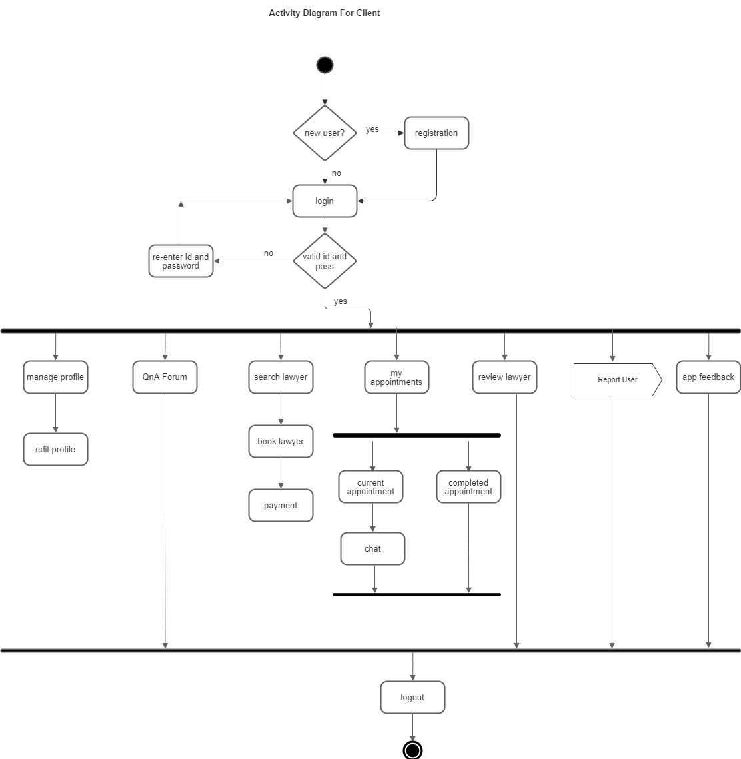

Fig. 1 Activity Diagram for Client

The above figure explains what kind of activities a client can perform such as registration, login, and then after login they can manage profile, search lawyers, book appointment with lawyer, can check their appointments, review lawyers, can go to QnA forums to see the different questions and answers. They can also report to the fake id.

Similarly, for lawyers the below figure explains what kind of activities a lawyer can perform such as registration, login, and then after login they can manage profile, can check their appointments, can go to QnA forums to see the different questions and answers. They can also report to the fake id.

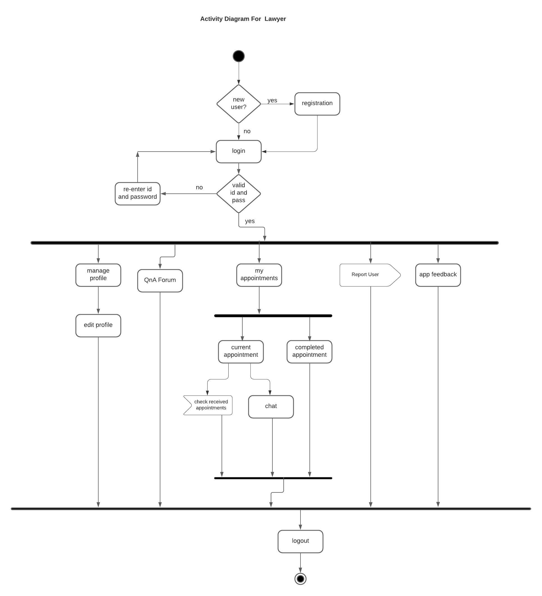

Fig. 2 Activity Diagram for Lawyer.

*A. System Requirements*

**III. IMPLEMENTATION AND RESULT**

*1)* Android Smartphone running Android version 5.0 or above

*B. Working*

Firstly, user has to register into the application as a client or lawyer. At the time of registration, the details of user are taken. So, for clients the details taken are name, email, password, dob, address, gender, mobile number. For lawyer, the same details are taken with an add-on i.e his area of expertise. After that the client can book appointment with lawyer. Also, can ask doubts related to it in the QnA forums. Clients can check lawyers profile and also review them. Here are some of the screenshots from our developing app.

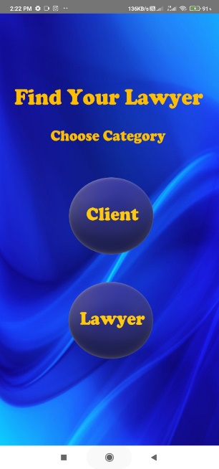

**IV. CONCLUSION AND FUTURE WORK**

It is an application for lawyers and clients to search for each other digitally. So, it saves time to go here and there and look for a lawyer. In this project, we create login and registration pages using Android Studio and link to the database. We have used the Firebase as a database. We have started designing the layouts of other pages of the application.

In the future, we will add lawyer recommendation. We will try to make the app more user friendly and easy to use.

**REFERENCES**

[1] “LegalMatch”: www.legalmatch.com

[2] “LawRato”: www.lawrato.com

[3] “Vkeel”: www.vkeel.com

[4] “Lawyer App”, Author: Al-saud Salman, “US Patent Application Publication - 20170046805”

[5] “Android”: https://developer.android.com/docs

[6]